Now **vary the packet size and observe the metrics**. Take packet size [128,256,512,1024,2048] bytes and collect the throughputs for each of them. Plot the packet size vs Throughput in this case and explain the graph.

**Answer** → Here is the screenshot of all different data packets and its throughputs.

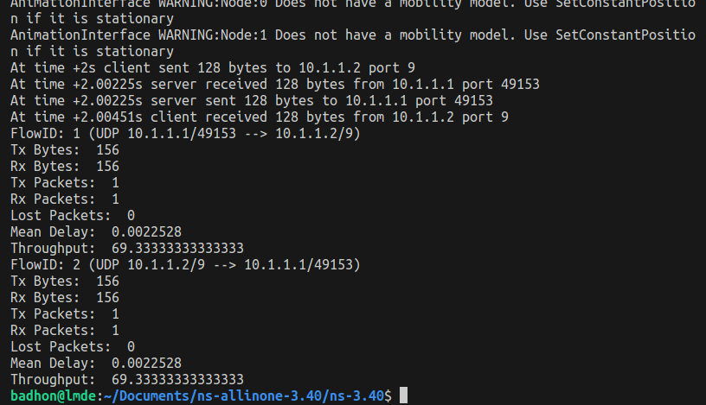

**Image of packet size 128**

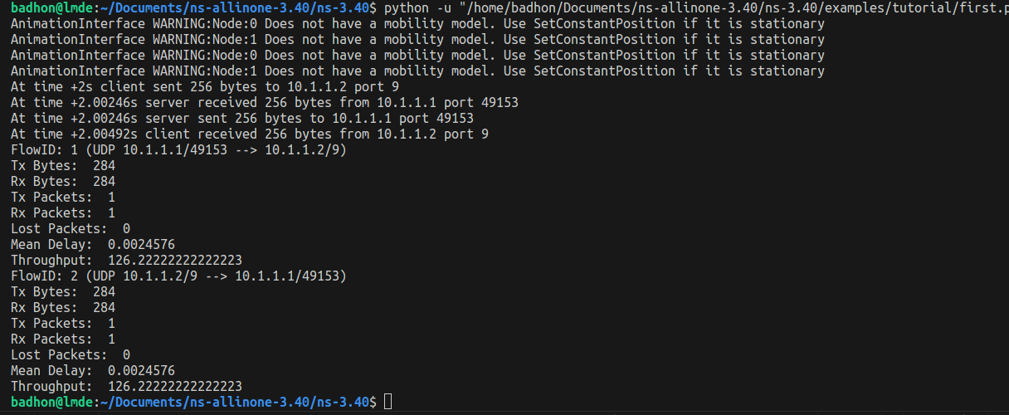

**Image of packet size 256**

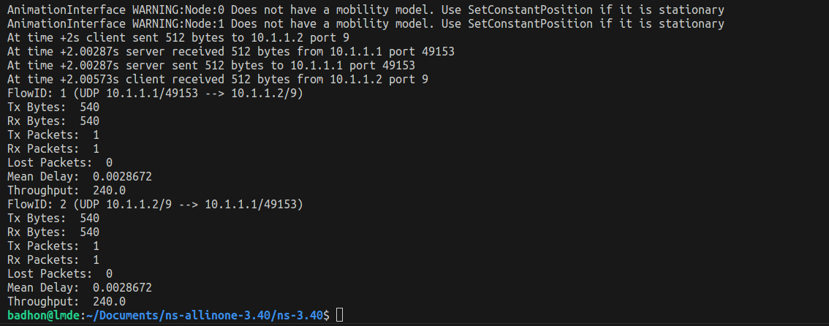

**Image of packet size 512**

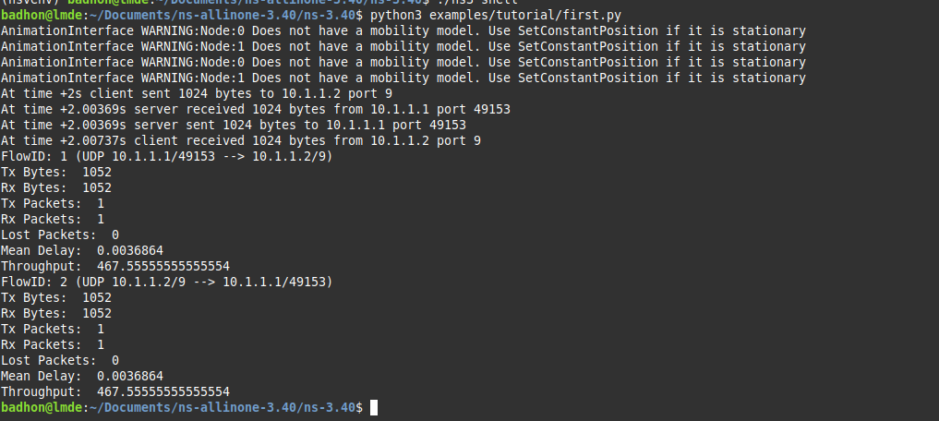

**Image of packet size 1024**

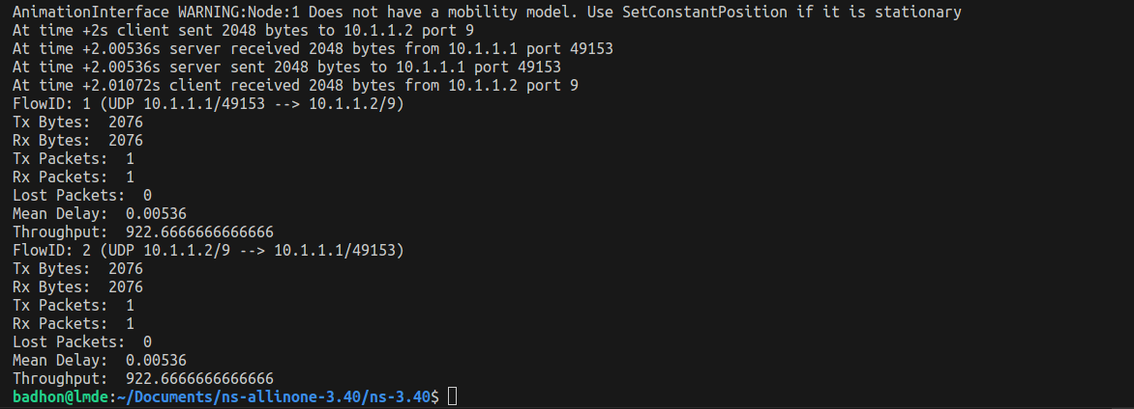

**Image of packet size 2048**

Here, the X axis will be packet, and the Y axis will be throughput. So the coordinates will be (128, 69.33), (256, 126.22), (512, 240), (1024, 467.56), and (2048, 922.67).

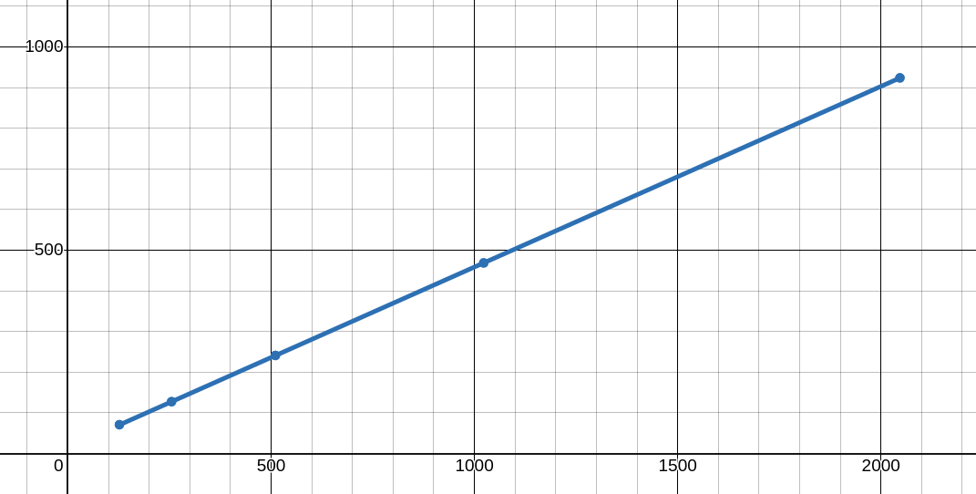

Graph Link: <https://www.desmos.com/calculator/b5sktzakqt>

This graph shows throughput increases with the packet size.